**Q.1 - Perform motion analysis for the following cam-follower mechanism as required. SolidWorks files for all parts are attached with assessment .**

**Q.1.1 - Assemble all parts to build assembly as shown above. Keep distance between bottom of the block and cam center as 5 inches.**

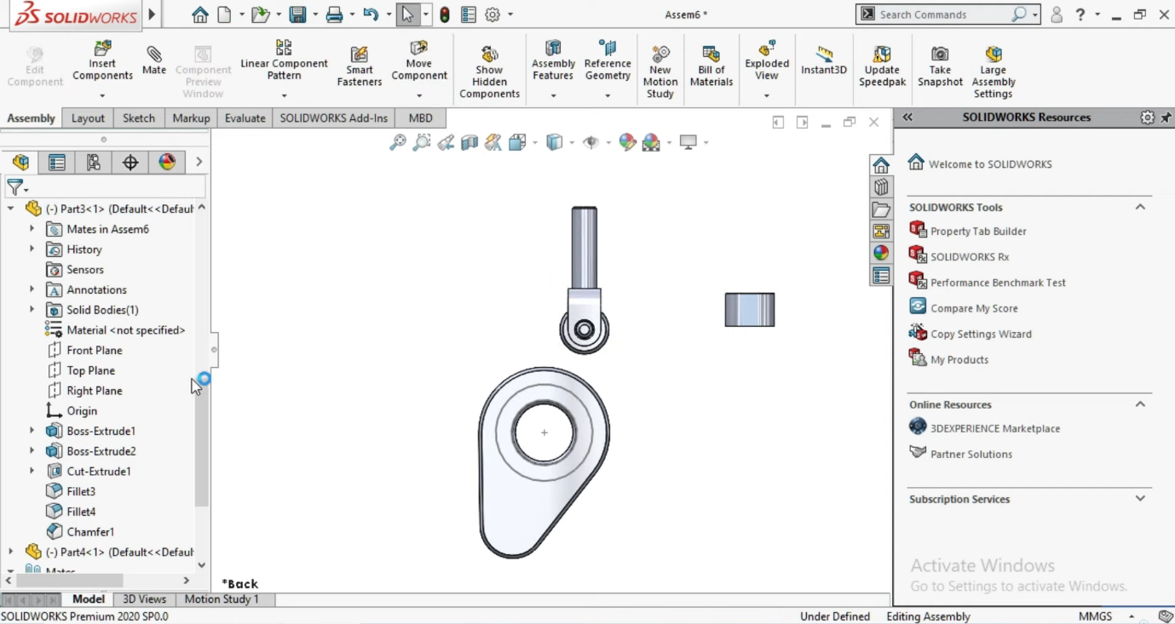

This are the cam and follower design and distance between block and cam is 5 inches .

**Q.1.2 - Assign material for cam as steel (ASTM A36), follower as aluminium (1060 Alloy) and block as steel (AISI 1020).**

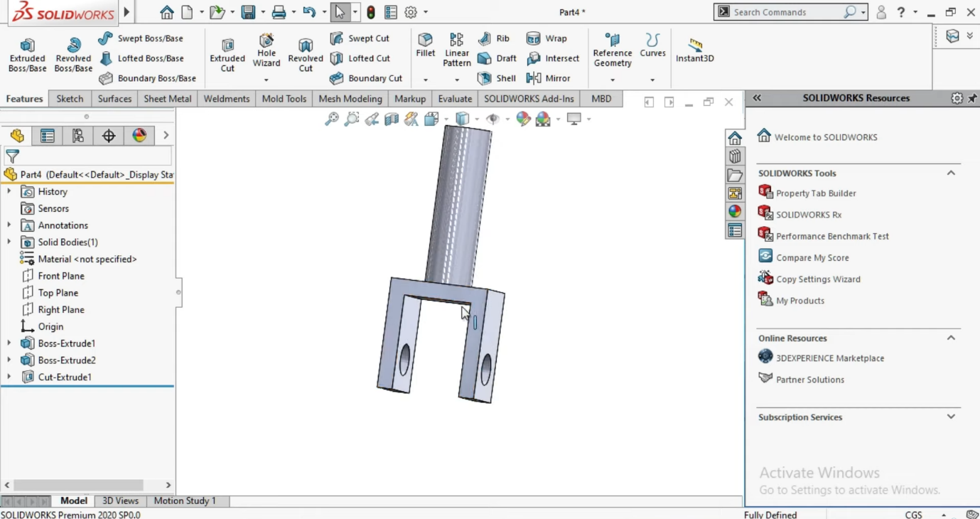

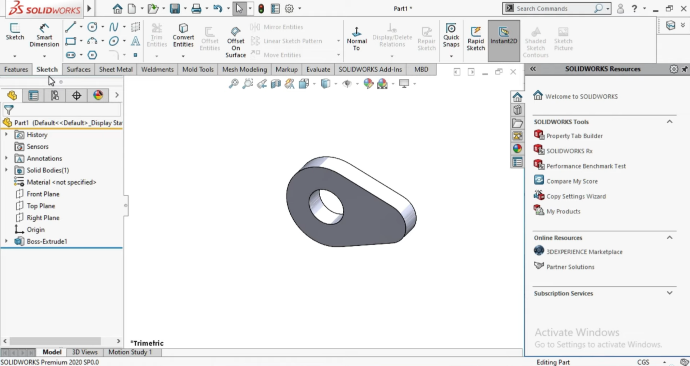

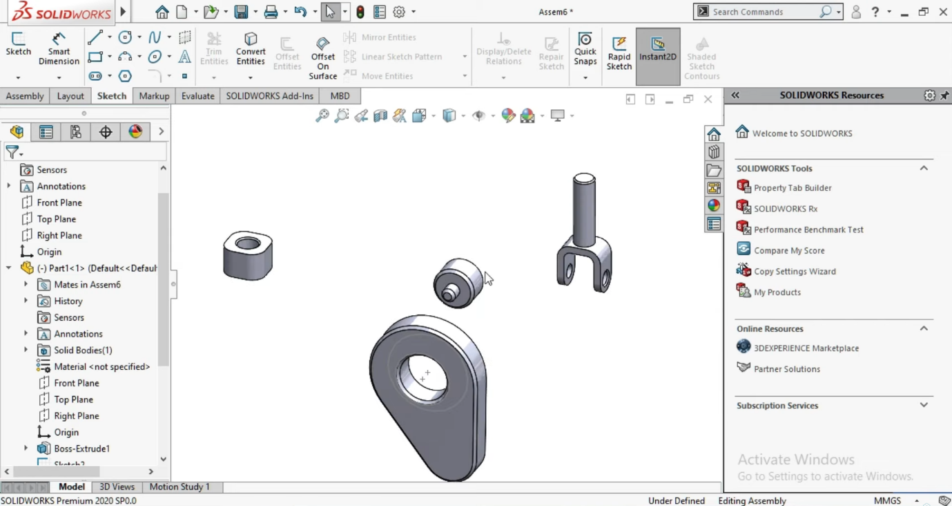

This all material used as given .

**Q.1.3 - Perform motion analysis to obtain velocity, acceleration and displacement (from the top of block ) for the top point of the follower. Rotate cam (clockwise) for 4 revolutions by using a motor of 120 rpm at the centre of cam. Apply gravity in the downward direction. Attach screenshots for the motion analysis setup, velocity, acceleration and displacement plots .**

As following some screenshots of rotation of cam and follower .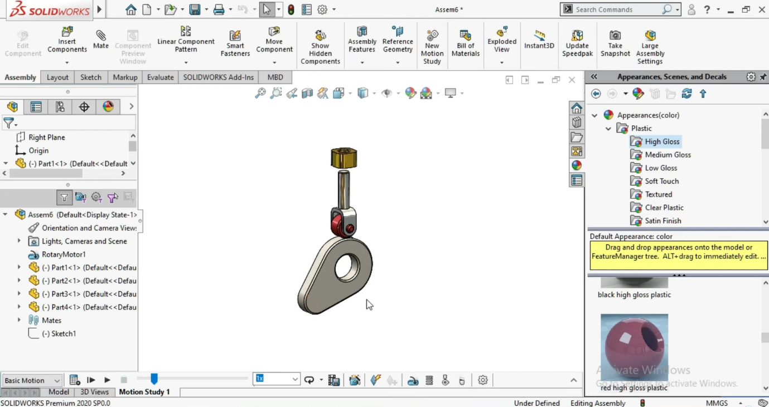

**Q.1.4 - Perform motion analysis to obtain velocity, acceleration and displacement (from the top of block ) for the top point of the follower by attaching spring of 50 lbf/inch in between the block and follower. Attach screenshots for the motion analysis setup, velocity, acceleration and displacement plots.**

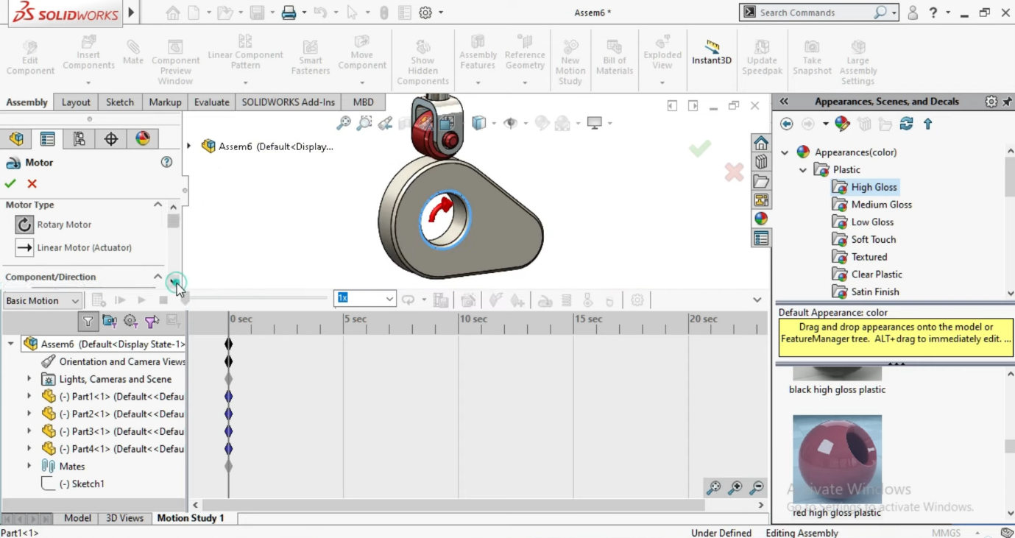

This are the screenshot of rotation .

**Q.1.5 - Comment on the comparison of results obtained in 1.3 and 1.4 .**

* **Cam Profile Creation**: You may have used SolidWorks sketching tools to define a cam profile. This step is important because the cam profile directly affects the speed of the followers. Ensuring smooth transitions and correct geometry is important to avoid jerky or uneven movements in the followers.
* **Follower Characteristics and Velocity Definitions**: Followers can be of different types - knife-edge, roller, flat-face, etc. Each method has a different effect on contact stress and wear Speed ​​definition determines follower rise, stay and fall times to check that cam profile of these requirements fill in the blanks.
* **Simulation and preliminary resu**lts: Running a preliminary simulation in SolidWorks helps to visualize the movement of the followers. Key parameters such as displacement, velocity and acceleration will be analyzed. It will be key to recognize any differences between intended and real movements, and to ensure the user moves smoothly and without interference
* **Motion smoothness**: The original design in 1.3 may exhibit some errors in motion, which are addressed by optimization in 1.4. Advanced analysis helps optimize cam profiles for smooth follower movement, reducing the chances of jerky or unpredictable actions
* **Stress distribution**: A stress distribution of 1.3 may exhibit high levels in some areas, indicating potential failure areas. 1.4 investigates these areas in more detail, and adjusts the cam profile to distribute the stress more evenly, increasing tool longevity and reliability
* **Realistic performance**: Preliminary results provide a theoretical understanding of the performance of Cam and his followers. However, the detailed analysis of 1.4 considering real-world constraints provides a more accurate prediction of how the system will behave under real operating conditions This includes better information about damage, intermediate required remediation , and the overall sustainability.

**Q.2 - For the given figure below, write appropriate G-code as required .**

* **G-code as following :**

O1000 ; Program range

; 2.1 Select relative coordinate machine

G91

; 2.2 Set spindle speed as 3000 clockwise

M03 S3000

; 2.Three Select device as T5

T5 M06

; 2.4 Move tool from beginning to factor A

G00 X2 Y5

; 2.Five Move device from Point C to factor D

G00 X3 Y0

; 2.6 Move device from factor G to I

G00 X10 Y-1

; 2.7 Move tool from factor I to J

G00 X1 Y-five

; 2.8 Move device from F to G

G00 X-5 Y1

; 2.Nine Move tool along Z-axis via 0.1 inch

G00 Z0.1

; 2.10 Switch off the coolant

M09

; 2.11 End program

M30

* **Explanation :-**

G91 sets the gadget to incremental positioning.

M03 S3000 activates the spindle in a clockwise route at 3000 RPM.

T5 M06 selects device 5.

G00 commands are used for speedy positioning.

Coordinates following G00 suggest the movement to specific factors.

M09 turns off the coolant.

M30 ends the program.

**Apply Group technology concept using rank-order clustering technique for the following parts machined on different machines. Suggest the best possible solution with your expert comments. Show/Highlight all your working steps. If you are using spreadsheet, insert appropriate screenshots.**

* **Step 1 :**

Construct the initial binary matrix (already provided):

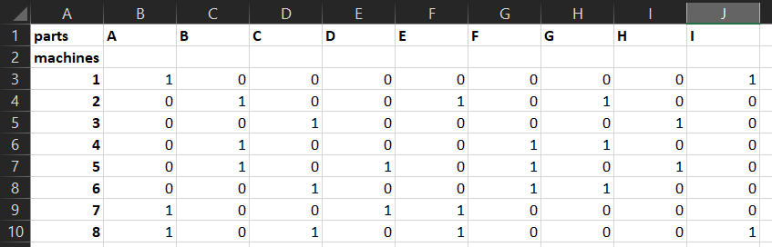

* **Step 2 :**

Calculate the decimal equivalent for each row &

Arrange rows in descending order of their decimal value:

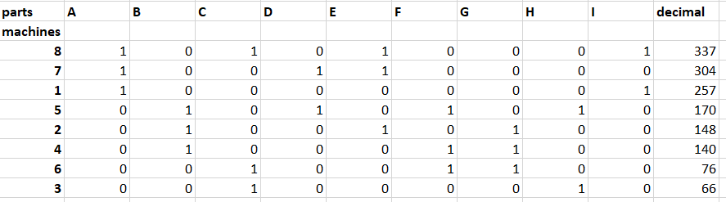

* **Step 3 :**

Calculate the decimal equivalent for each column &

Arrange colums in descending order of their decimal value:

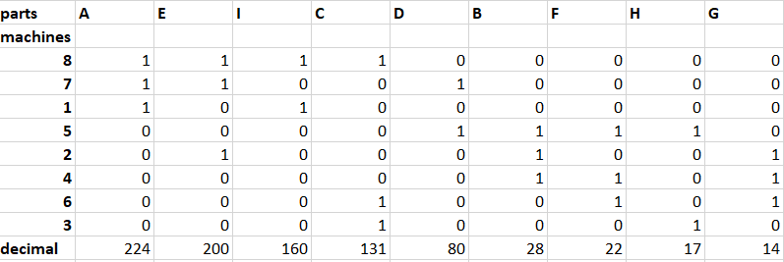

**Comments :**

* The reordered matrix shows the parts and machines grouped more efficiently.
* Machines and parts that are frequently used together are placed closer to each other.
* This clustering minimizes the movement and setup times, enhancing production efficiency.
* This reordering reveals the part families and machine groups more clearly, which helps in organizing the production process to maximize efficiency and reduce setup times.

**References :**

* Bi, Z., & Wang, X. (2020). Computer Aided Design and Manufacturing. Wiley. ISBN: 978-1-119-66788-9.
* Xu, X. (2009). Integrating Advanced Computer-Aided Design, Manufacturing, and Numerical Control: Principles and Implementations. Information Science Reference. ISBN: 978-1-59904-899-9.
* Nee, A. Y. C., & Xu, X. (Eds.). (2009). Advanced Design and Manufacturing Based on STEP. Springer. ISBN: 978-1-84882-739-4.
* Xu, Xun. (2009). Integrating Advanced Computer-Aided Design, Manufacturing, and Numerical Control: Principles and Implementations. Information Science Reference. ISBN: 978-1-59904-716-4.
* Harik, R., & Wuest, T. (2019). Introduction to Advanced Manufacturing. SAE International. ISBN: 978-0-7680-9096-3.
* Evans, J. M. Jr. (1976). National Bureau of Standards Information Report (NBSIR) 76-1094 (R): Standards for Computer-Aided Manufacturing. National Bureau of Standards.
* Oberg, E., Jones, F. D., Horton, H. L., & Ryffel, H. H. (1996). Machinery's Handbook (25th ed.). Industrial Press. ISBN: 978-0-8311-2575-2.